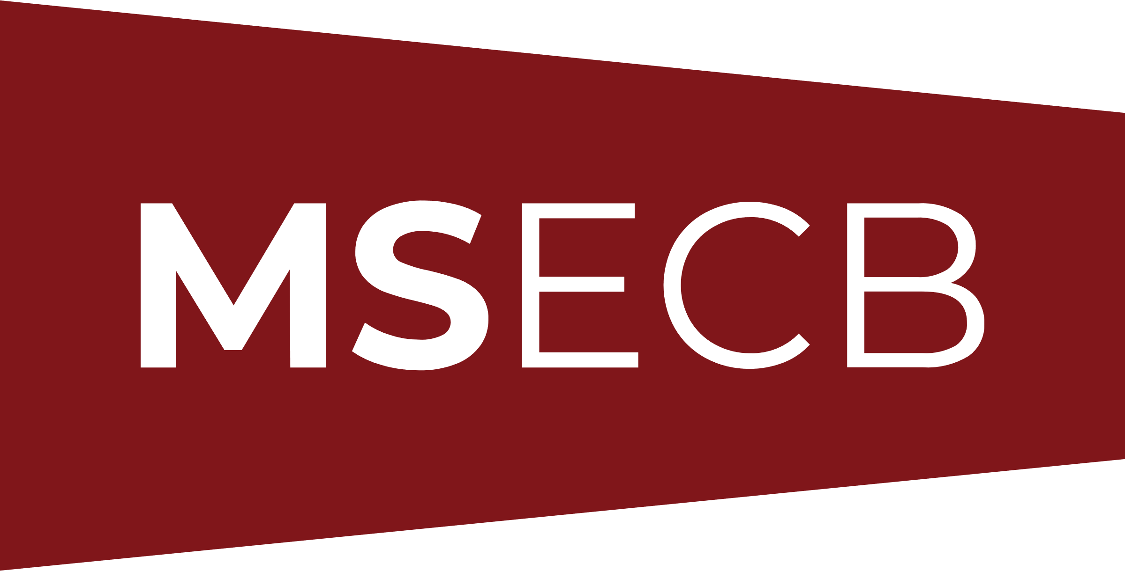

AUDIT PLAN

Audit information

Organisation Name:
Address:
City/Country: |  | ZIP Code:
Contact Name: |  | E-Mail:
Web Site: |  | Telephone:

Total number of employees within the scope:

Please provide justification for the employees that are not included in the certification scope.
Site # | Street Address | City | State, Province, Country | Zip Code | # of Employees
1 (main)
2
3
4

Audit standard(s):
Audit type: | ☐ Initial Audit | ☐ Surveillance 1
 | ☐ Recertification | ☐ Surveillance 2
 | ☐ Other:
Dates of audit:
Duration:
Audit team leader:
Additional team members:
Additional attendees and roles:

Certification Scope:
Excluded clauses from the certification scope:
For QMS audits, please provide justification for each excluded clause:

Audit preparation

Audit objectives
The objectives of this audit are to:
- confirm that the management system conforms with the requirements of the audit criteria;
- confirm that the management system meets applicable statutory, regulatory and contractual requirements;
- confirm the effectiveness of the management system in meeting its specified objectives;
- identify areas for potential improvement of the management system.

Audit criteria
The audit criteria (the set of requirements) for this audit are all normative clauses of the standard being audited (specify all clauses as written in the Standard):
- Clause 4 – …
- Clause 5 – …
- Clause 6 – …
- Clause 7 – …
- Clause 8 – …
- Clause 9 – …
- Clause 10 –…
- Additional requirements
  - Use of logo and trademark
  - Verification of Adverse events, advisory notices and recalls (when applicable)
  - Documentation and processes defined in the management system developed by the client

Audit plan

Date:
Time | Auditor | Area / Process | Key Contact

Date:
Time | Auditor | Area / Process | Key Contact

Notes

- The scheduled times indicated in the audit plan are approximate. MSECB Auditors reserve the right to change or add information to the above audit plan before or during the audit as needed.
- During each stage 2 and surveillance audits the following should be verified:
- Internal audit
- List of all applicable documents in the audited management system
- Management review
- Preventive and corrective actions
- Continual improvement
- Continuing operational control
- Effectiveness of the MS to meet organizational objectives
- Changes to the MS documentation
- Actions take on nonconformities found during the last audit (if applicable)
- Complaints and use of certification marks (if applicable)

