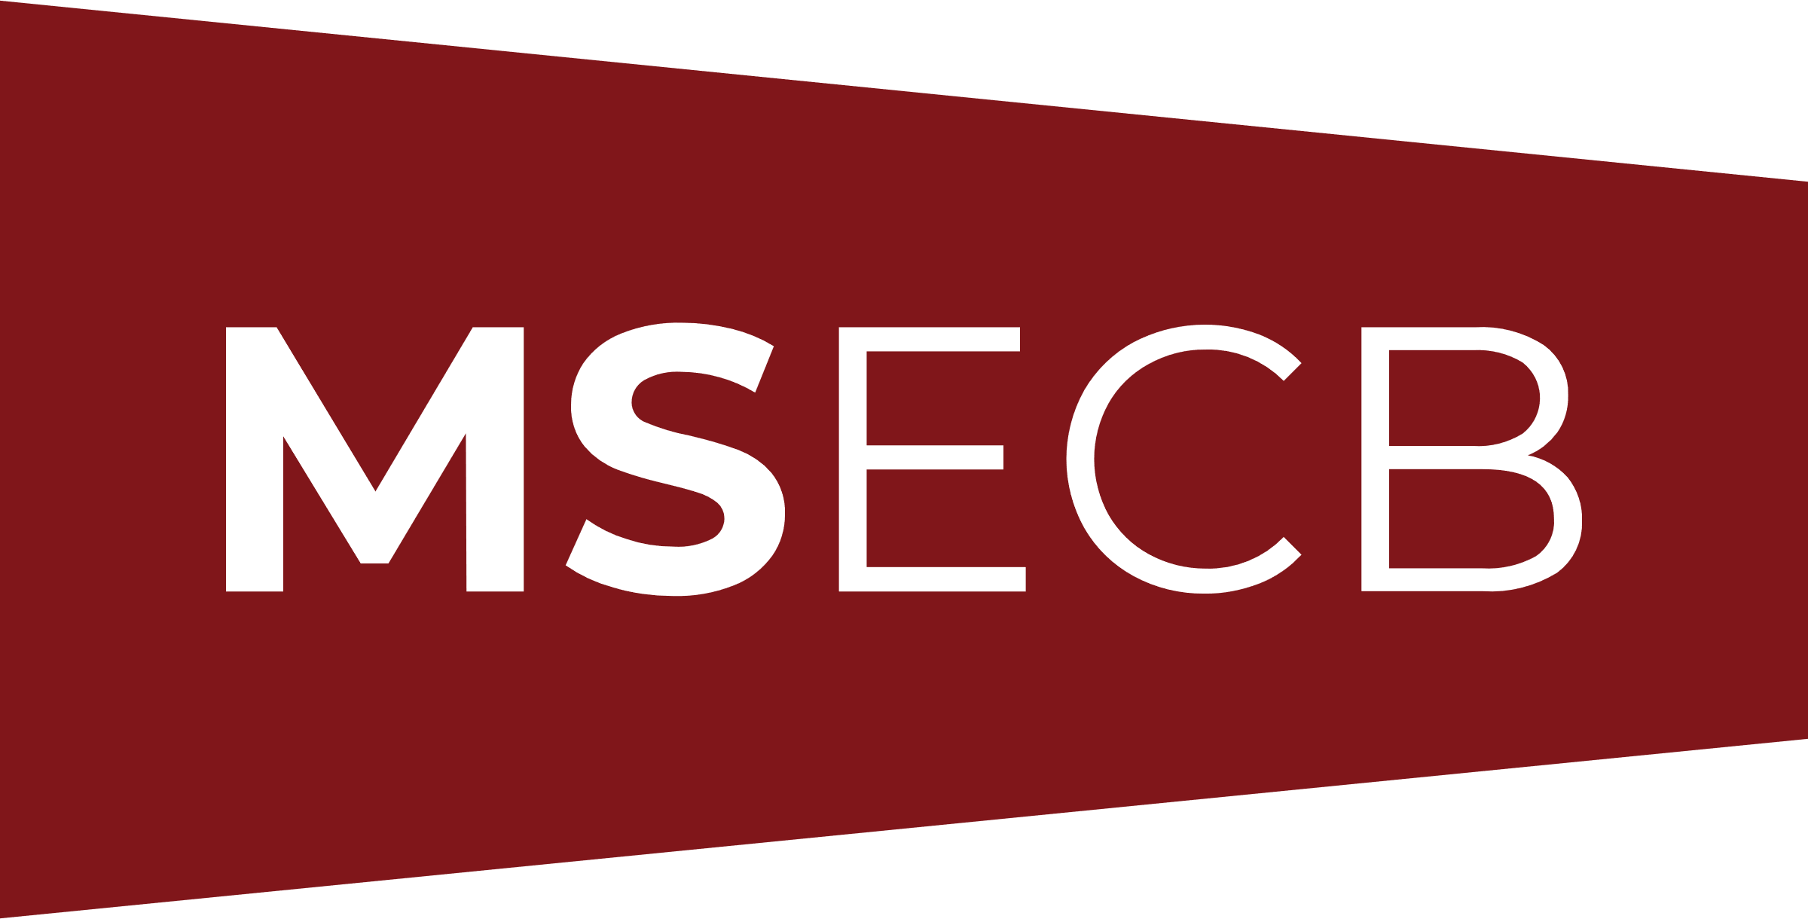

AUDIT REPORT
Stage 1

Organization:
Address:
Other locations
if applicable
Auditee representative:
Standard(s) audited:
Lead Auditor:
Other team members:
Dates of audit:
Audit duration:

Audit objectives
The objectives of this audit are:

- To review the management system documentation;
- To review the client’s status and understanding of the requirements of the standard;
- To obtain necessary information regarding the scope of the management system;
- To determine preparedness for stage 2;
- To review the allocation of resources for stage 2 and agree the details of stage 2;
- To evaluate if internal audits and management reviews are being planned and performed.

Audit Scope
The audit scope is as follows:

The audit is multi-site. | Yes ☐ No ☐ N/A ☐
All scope exclusions are appropriate and justified. | Yes ☐ No ☐ N/A ☐

Critical audit findings
Critical audit findings were discovered (please list critical findings below, if any were discovered). | Yes ☐ No ☐

Non-critical audit findings
Non-critical audit findings were discovered (please list non-critical findings below, if any were discovered). | Yes ☐ No ☐

Opportunities for improvement
The audit team has identified the following opportunities for improvement (please list opportunities for improvement identified, if any).

Audit conclusions
The management system is designed to conform with all the requirements of the standard | Yes ☐ No ☐
The management system is designed to achieve the organization’s policy objectives | Yes ☐ No ☐
The management system is designed to meet statutory, regulatory and contractual requirements | Yes ☐ No ☐
The internal audit and management review processes are in place and adequate | Yes ☐ No ☐
The audit was successful in meeting the stated objectives | Yes ☐ No ☐
The client is ready for Stage 2 | Yes ☐ No ☐

Disclaimer
This audit is based on a sampling process of the available information and the auditors nor MSECB can guarantee that all, if any, non-conformities have been discovered.

